**Roshaan tariq khan 19781**

**Data: Pakistan available jobs**

**Wrangling steps:**

* removed label column as many null values
* removed JD column, not useful
* renamed to appropriate column names
* group students and graduates to No Exp. In experience column
* two entries had the same meaning with different spelling, changed jobs to job so they can be grouped into one
* removed job type column as useless
* removed null rows as adding some company would make the data inconsistent

**Paper charts:**

* Following are the potential charts that can be added to describe the data
* Charts can be changed or look just like the paper charts



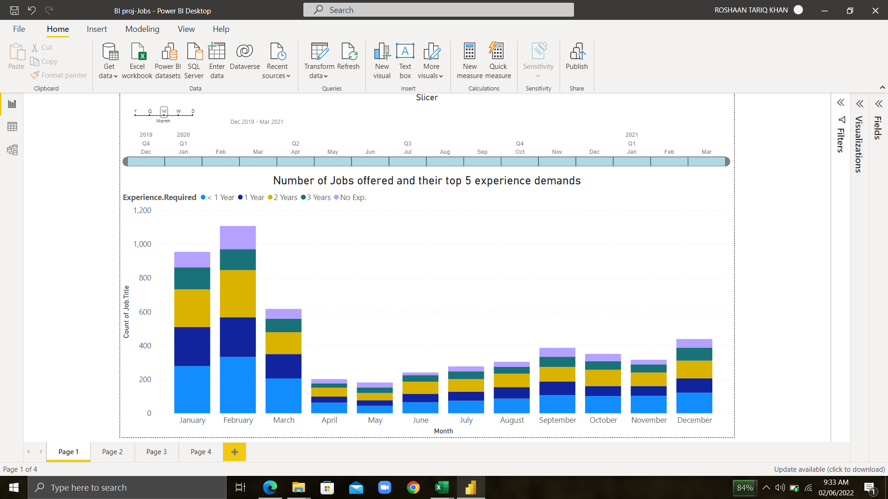**Chart Analysis:**

* The stacked column chart shows that the months of January and February offered the most jobs , reason could be that it’s the start of the year and companies try to change their strategies to meet different goals and hence, require fresh employees to meet them. The slicer is used to zoom in on desired months for more info. Fresh graduates with little experience will have a good time as multiple jobs are available for them through out the year.

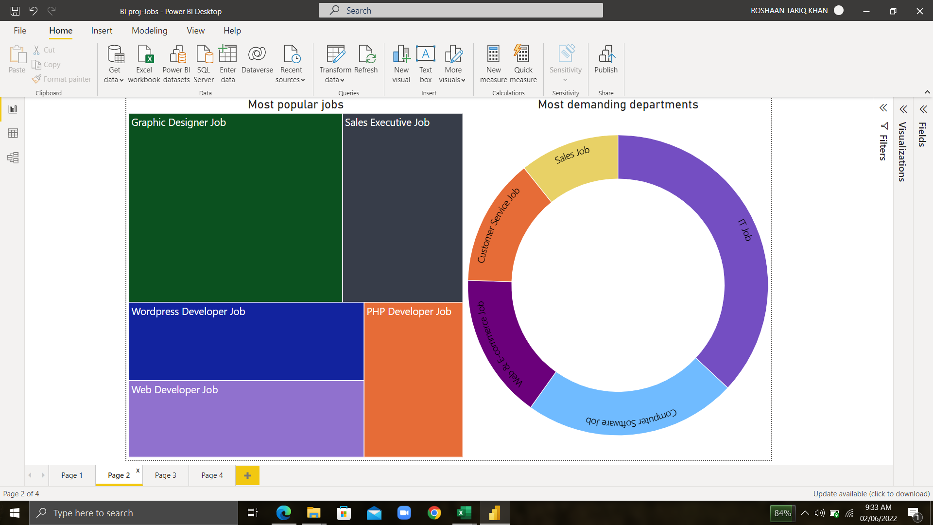

* The tree map shows the most popular jobs according to the data and similarly had the most job openings. It seems like the Computer science related jobs heavily dominate the market these days.
* The donut chart shows the most demanding departments with IT job on top , alongside computer software in second place and Web and ecommerce job in the third. This chart further exacerbates the facts listed on the tree map that indeed IT related jobs are the most in-demand.
* 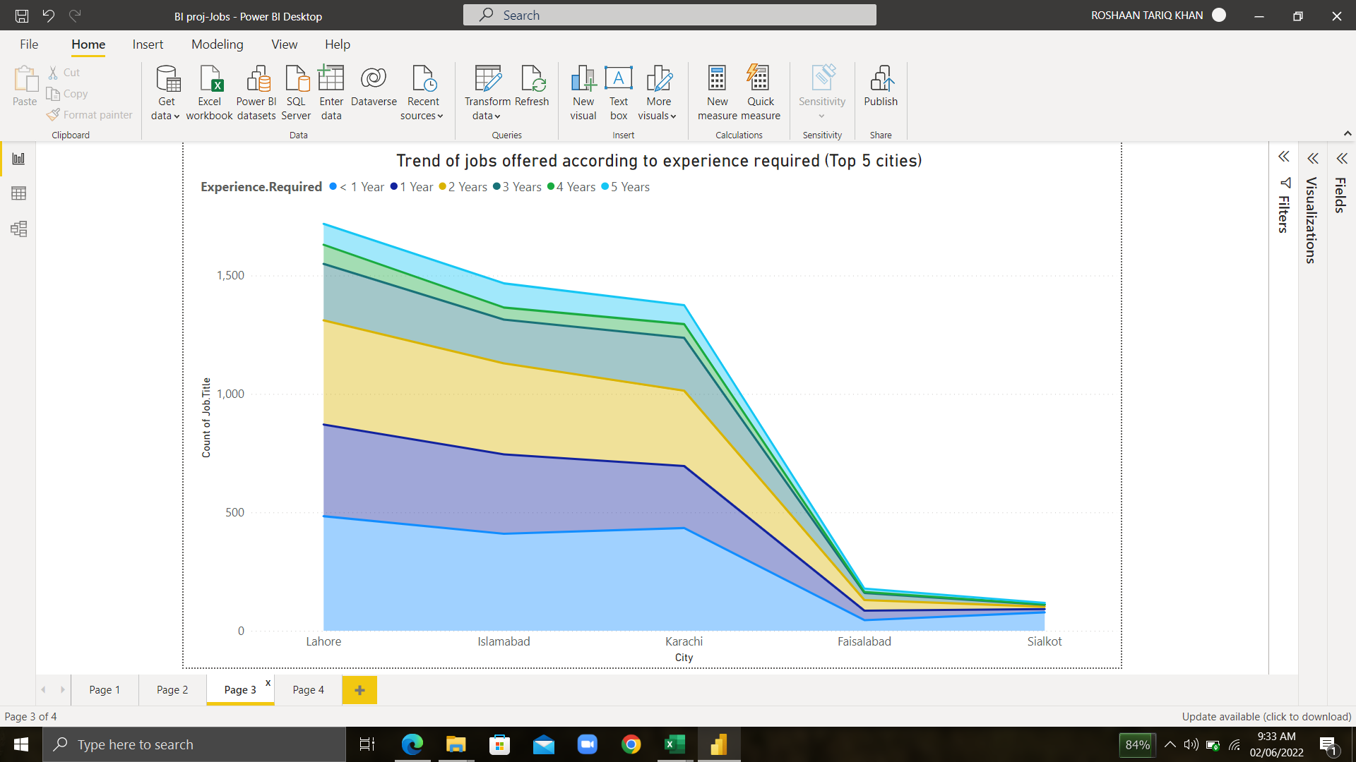Oddly enough, Karachi falls short when offering jobs compared to Lahore and Islamabad. One reason might be that the data is biased towards Lahore as more data might have been collected over there. My problem statement asked the question, Which city offers the most jobs for young graduates? (1-2 yr exp). It looks like Lahore offered the most jobs for young graduates requiring the experience from <1 year to 2 years, young graduates will have plenty of opportunities in Lahore. Islamabad and Karachi aren’t too far behind either but Faisalabad and Sialkot should not be recommended when searching for a job.
* 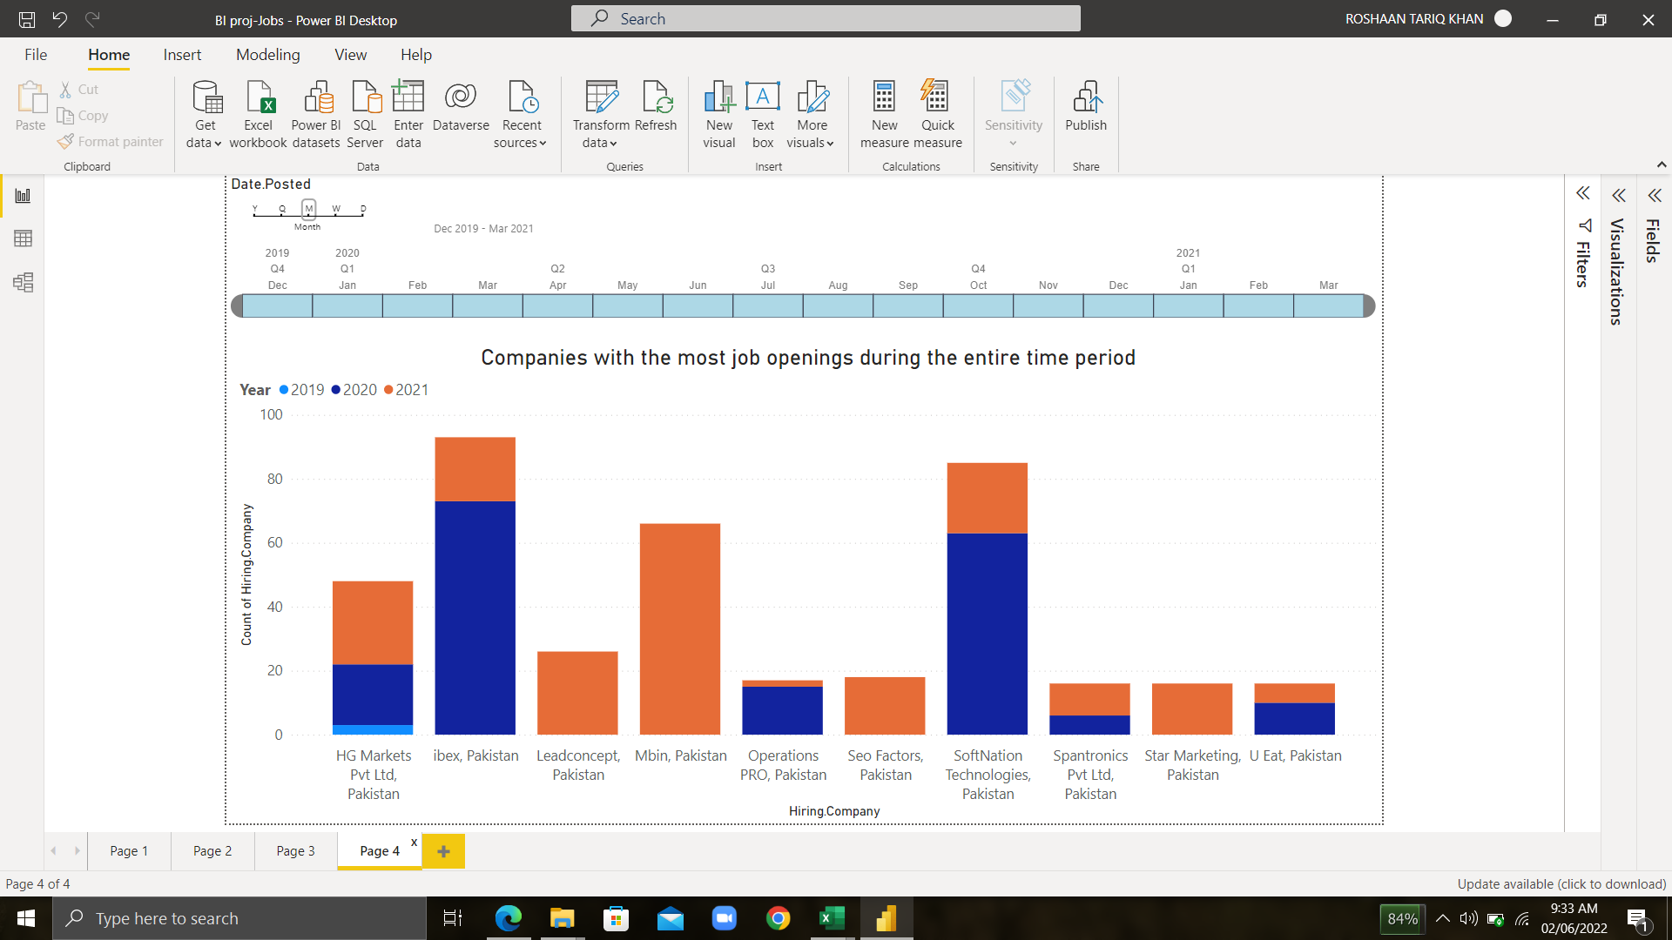Finally, to answer our first problem statement which company has offered the most jobs during the period? Ibex and softnation technologies have offered the most jobs during the entire period. The year 2020 looks like it included a lot of work from home IT jobs due to covid as it can be seen that softnation technologies offered bulk of their offerings during that time.
* Other than that, some companies offered no jobs during 2019, 2020, reason could be that they were struck by covid and couldn’t afford new employees. Job searchers will have more of a chance applying to these top 10 companies as they offered a variety of jobs.